**Day 4**

Exploring Docker

1. Docker environment Variables

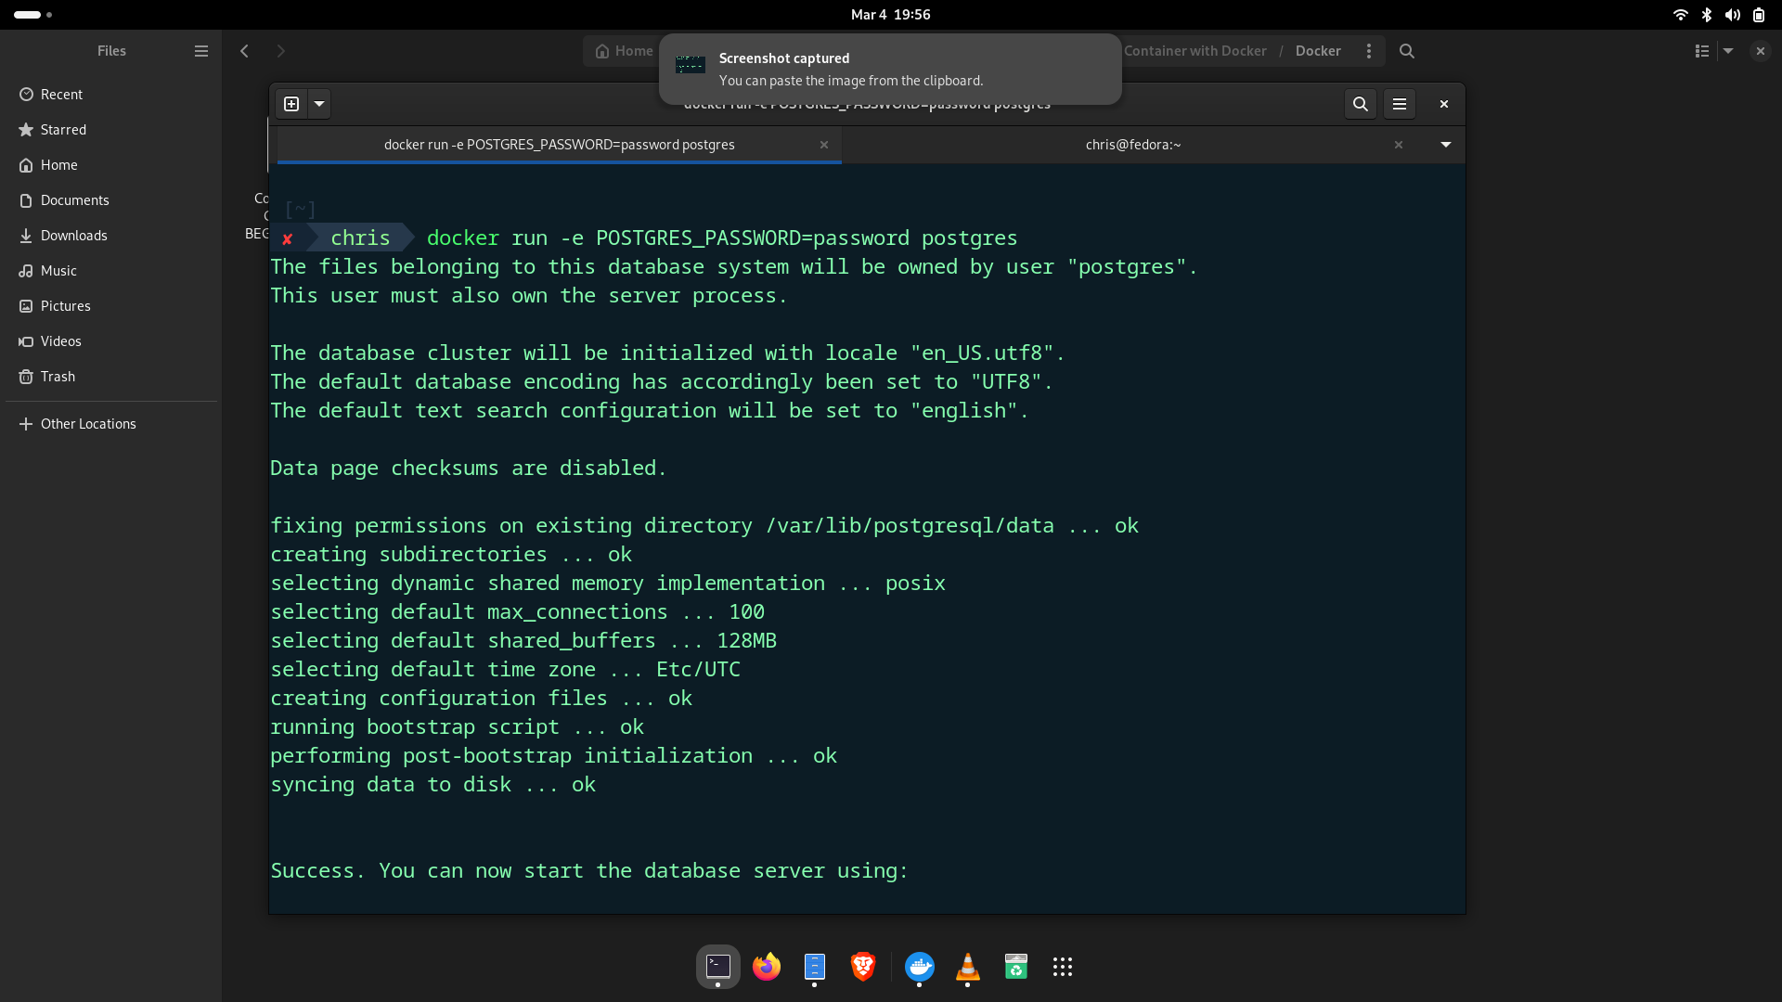

1. Whenever we are running and docker run command It will create new Container instance

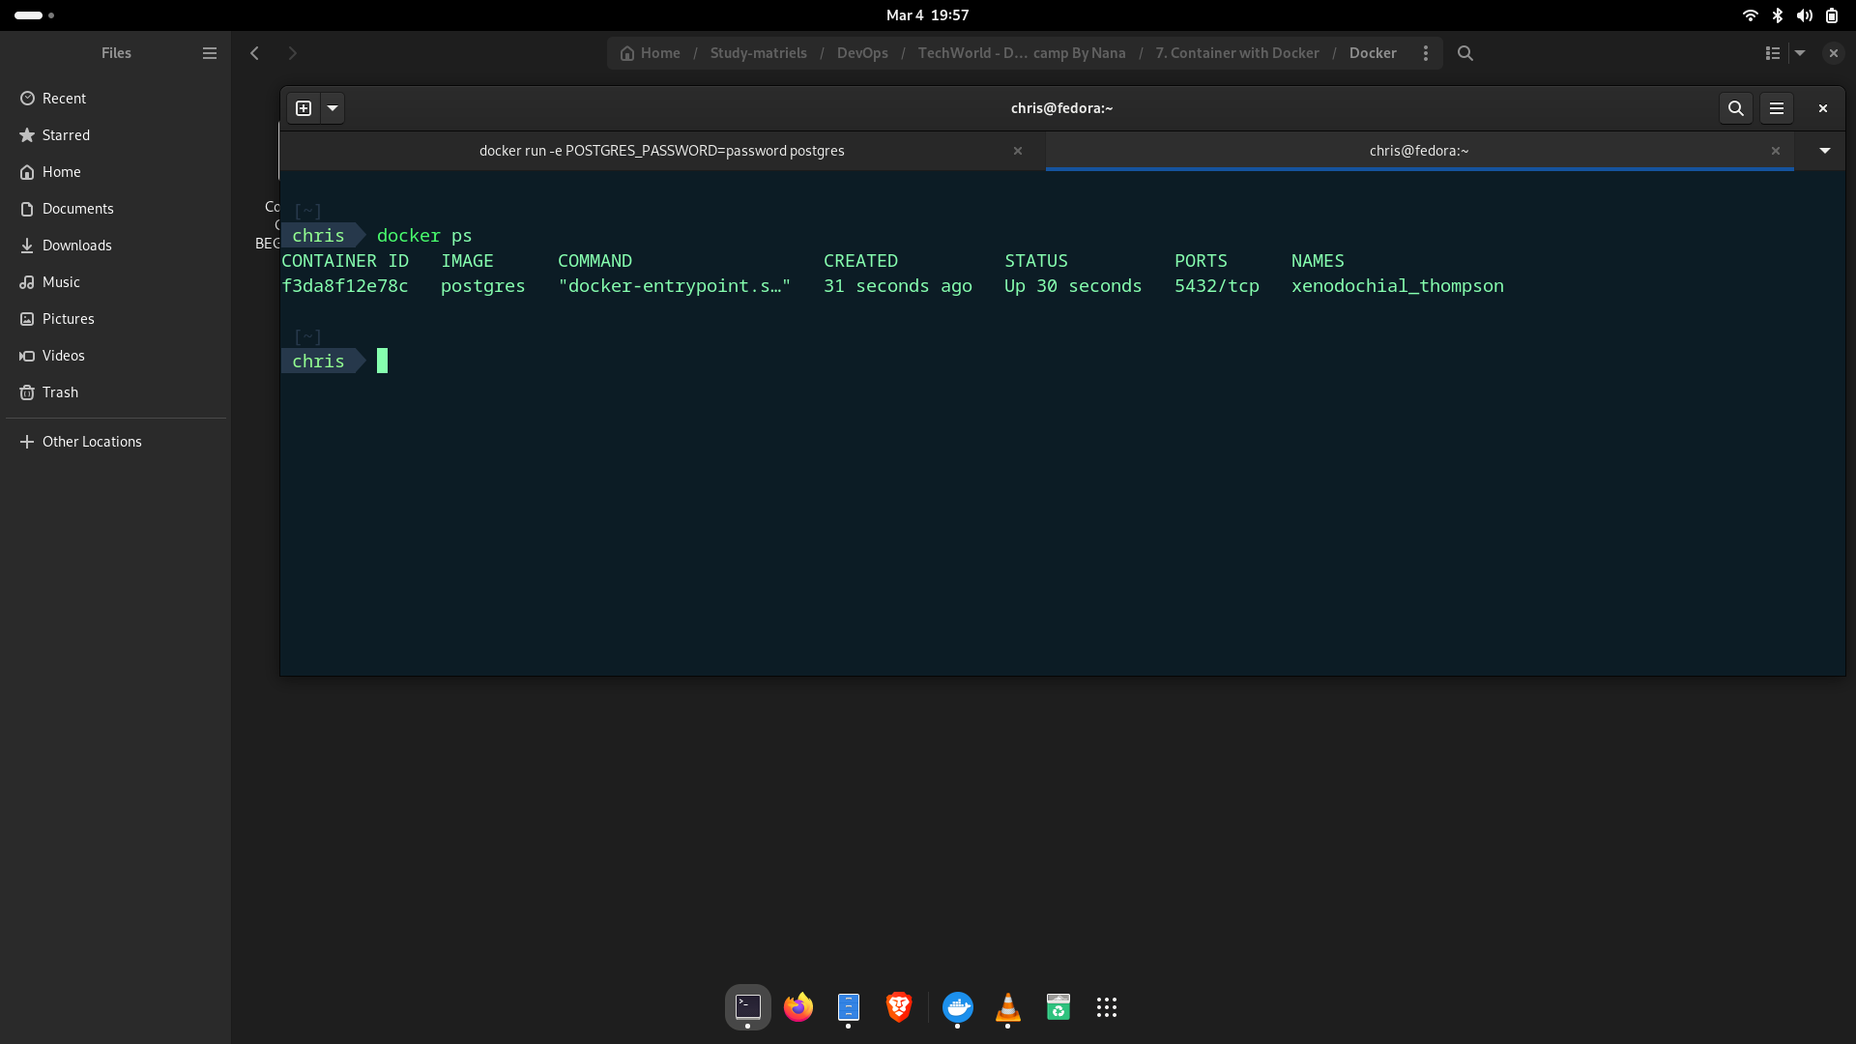

1. Docker logs <ID> -> To see the logs of specific container
2. Docker rmi <images> To remove images from the docker

